PROTOTYPE OF MAP 1.0 1ST PROTOTYPE – 2D MAP
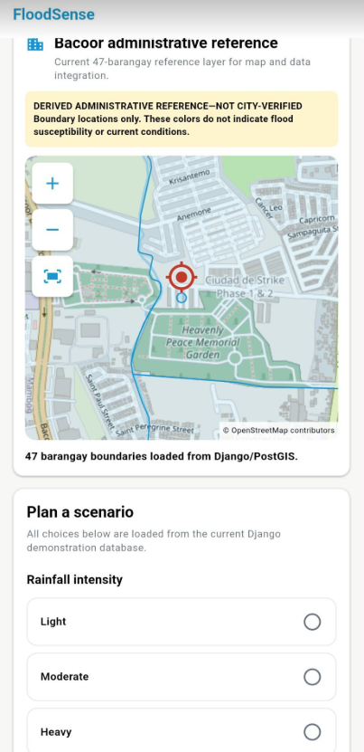

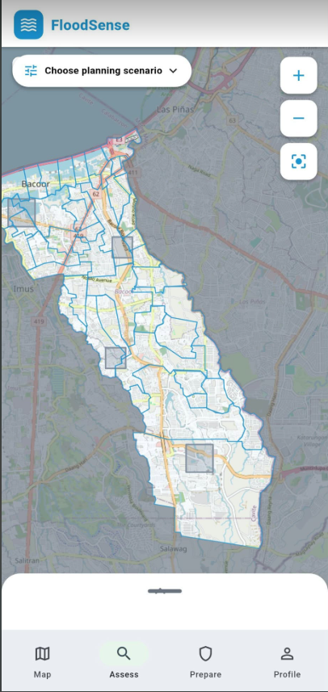
NEXT PROTOTYPE OF MAP 2.0, 2ND PROTOTYPE – OSM MAP

3RD PROTOTOYPE OF THE MAP – 3D MAP
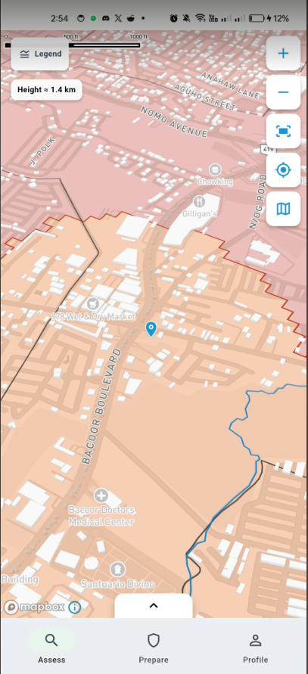

LOG IN PAGE PROTOYPE 1, 1ST PROTOTYPE
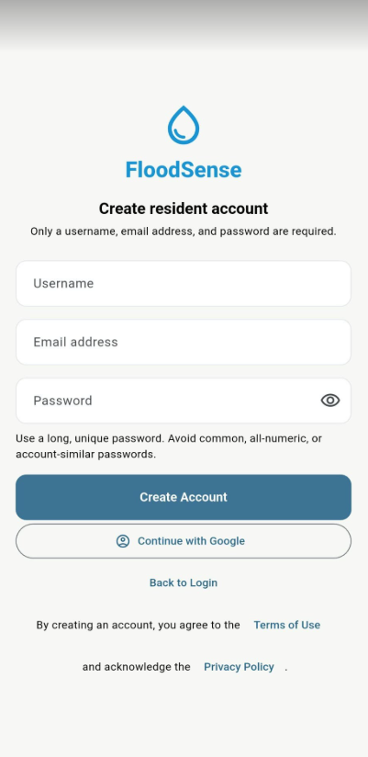

LOG-IN PAGE 2ND PROTOTYPE
